1. Which form of mercury was the predominant cause of Minamata Bay disease? OK
A) metallic mercury
B) mercuric salts
C) mercurous salts
D) organic mercury compounds: (C&D Pg 947): A well-known organomercurial poisoning episode was from consumption of fish contaminated with methylmercury from industrial waste in Minamata, Japan.
E) mercury was not the causative agent

2. Methyl bromide (CH3Br):
A) is a liquid used primarily as a fumigant (incorrect) (Ethylene dibromide is liquid form) They can be liquids that readily vaporize (e.g., ethylene dibromide), solids that can release a toxic gas on reaction with water (e.g., phosphine released by aluminum phosphide), or gases (e.g., methyl bromide). (C&D pg 921)
B) has essentially no warning properties, even at physiologically hazardous concentrations:
"Methyl bromide is a dangerous cumulative poison with delayed symptoms of central nervous system intoxication that may appear as long as several months after exposure. High concentrations can produce fatal pulmonary edema. Chronic exposure can cause central nervous system depression and kidney injury. It may cause severe and permanent brain damage. Severe neurological signs may appear when there is a sudden exposure to high concentrations following continuous slight exposure. Methyl bromide has practically no odor or irritating effects and therefore no warning, even at hazardous concentrations. (EPA, 1998) [emphasis added]". Source: http://cameochemicals.noaa.gov/chemical/1091

C) is extremely flammable: Methyl bromide is non flammable
D) is of greater concern from its oral toxicity than from its inhalation toxicity
E) would not be expected to be readily absorbed through the lungs: In humans, methyl bromide is readily absorbed through the lungs. Most problems occur as a result of inhalation. About 1,000 human poisoning incidents caused by methyl bromide exposure have been documented, with effects ranging from skin and eye irritation to death. Most fatalities and injuries occurred when methyl bromide was used as a fumigant. (Cornell University EXTOXNET)
http://pmep.cce.cornell.edu/profiles/extoxnet/haloxyfop-methylparathion/methyl-bromide-ext.html
The acute toxicity of methyl bromide relates to both its concentration and the duration of exposure. For example,LC50 values in rats were 2833 ppm for a 30 minute exposure, and 302 ppm for an 8 hour exposure

3. The chloronicotinyl compound imidacloprid demonstrates a high insecticidal potency and exceptionally low mammalian toxicity due to:
A) its high affinity for insect nicotinic acetylcholine receptors and low affinity for mammalian nicotinic acetylcholine receptors: Neonecotinoids: The main reason for their success lies in their selectivity profile, which is largely attributable to their specificity toward insect vs. mammalian nAChRs. The nAChR consists of diverse subtypes assembled in combination from ten α and four β, γ, δ, ε subunits. The most abundant subtypes in the vertebrate nervous system are α4β2 and α7, which are insensitive and sensitive, respectively, to α-bungarotoxin. In insects, neonicotinoids have been shown to bind to at least three pharmacologically distinct nAChRs (C&D pg 907)
B) the blood-brain barrier in mammals
C) the first pass effect in the liver in mammals
D) the low pH in the stomach of monogastric mammals
E) the presence of true acetylcholinesterase in mammals

4. The most commonly used pyrethroid synergist is (OK)
A) silica
B) piperonyl butoxide: Inhibition of cytochromes P450 by piperonyl butoxide indeed increases pyrethroid toxicity, and so does inhibition of carboxylesterase. Piperonyl butoxide is added to most pyrethroid formulations as a synergist. Inhibition of carboxylesterase may be of significance, if unauthorized pyrethroid/organophosphate mixtures are utilized. In fact, several organophosphates inhibit carboxylesterase activity, and may thus be expected to potentiate pyrethroid toxicity (C&D Pg 899).
C) methyl butyl ether
D) n-octyl bicyloheptene dicarboximide
E) toluene

5. Paraquat and diquat differ substantially in their (OK)
A) metabolism to a free radical: Like paraquat, diquat can be reduced to form a free radical and then reoxidized in the presence of oxygen, with the concomitant production of superoxide anion. This process of redox cycling occurs in the eye and is believed to be the likely mechanism of cataract formation (pg 914).
B) ability to initiate lipid peroxidation in vivo
C) uptake by the lung: Despite the chemical similarity to paraquat, the herbicide diquat presents a different toxicological profile. Acute toxicity is somewhat lower, with oral LD50 in rats of approximately 200 mg/kg. Diquat is not a skin sensitizer, has minimal or no genotoxic activity, is not carcinogenic in rodents, has no effect on fertility, and is not teratogenic. In contrast to paraquat, it does not accumulate in the lung, and no lung toxicity is seen upon acute or chronic exposure. Upon chronic exposure, target organs for toxicity are the gastrointestinal tract, the kidney, and particularly the eye. Diquat indeed causes a dose- and time-dependent appearance of cataracts in both rats and dogs (pg 914)
D) generation of superoxide anion in vivo
E) mechanism of cytotoxicity

6. Which of the following leads to deposition of oxalate crystals in the urinary tract?
A) Dieffenbachia (dumbcane)
B) propylene glycol
C) methoxyflurane
D) philodendron
E) ethylene glycol - For example, oxalic acid formed from ethylene glycol may cause acidosis and hypocalcaemia as well as obstruction of renal tubules by precipitation as calcium oxalate. C&D 8th ed., page 54.

7. A target organ of streptomycin-induced toxicity is
Streptomycin can affect the nervous sytem (hearing), blood (coagulation factors, aplastic anemia), skin (urticarial)
A) lung
B) heart - Aminoglycosides inhibit the uptake or binding of Ca2+ at sarcolemmal sites, thus reducing the concentration of membrane-bound Ca available for movement into the myoplasm during depolarization of the sarcolemma. C&D 8th ed., page 823.
C) reproductive system
D) kidney
E) liver

8. Which of the following is characteristic of a nongenotoxic carcinogen?
A) has no influence on the promotional stage of carcinogenesis- of course they do. They can increase the incidence of mutations in already initiated cells leading to promotion.
B) would be expected to produce positive responses in in vitro assays for mutagenic potential – not necessarily.
C) typically exerts other forms of toxicity and/or disrupts cellular homeostasis - As a second mode of action, nongenotoxic carcinogens may alter expression of critical genes by modifying the responsiveness of the promoter region of these genes to TFs. C&D 8th ed., page 113
D) generally shows little structural diversity
E) typically has little effect on cell turnover – false, they do have effects on cell turnover.

9. A single large dose of N-nitrosodimethylamine fails to induce cancer in rats, but repeated dosing induces cancer because
A) the single large dose is lethal, while the threshold for cancer induction can be exceeded by repeated smaller doses
B) the main DNA lesion from a single large dose can be repaired readily by methyltransferase, while repeated smaller doses can deplete the available repair enzyme, induce mutations in DNA, and effectively induce cancer
C) the enzyme system involved in detoxification of N-nitrosodimethylamine is depleted after repeated doses, allowing N-nitrosodimethylamine to build up and exceed the threshold for cancer induction
D) the enzyme system involved in conversion of N-nitrosodimethylamine to the active carcinogen is induced and on subsequent repeated doses more active carcinogen is produced
E) the initial dose of N-nitrosodimethylamine causes cell damage and, thus, high mitotic rates; subsequent small doses induce mutations in DNA and effectively induce cancer

10. Based on the available data, cyclosporin A-induced cholestasis is most likely explained by which of the following?
A) interaction with the cytoplasmic receptor, cyclophilin – This interaction inhibits the formation of IL-2. But this effect does not lead to cholestasis but to immune suppression.
B) inhibition of transcription of message (mRNA) for critical cytokines – It does inhibit IL-2 transcription. I don’t believe this effect leads to cholestasis but to immune suppression.
C) induction of programmed cell death in centrilobular hepatocytes
D) inhibition of ATP-dependent transporter(s) in the bile canalicular membrane – Various studies have shown that CsA can inhibit transport into the canalicular lumen.
E) depolarization of the mitochondrial membrane potential
11. The effluent from a municipal sewage plant induces plasma vitellogenin in trout. Which of the following is MOST likely the cause?
A) conjugated estrogens- http://www.ncbi.nlm.nih.gov/pubmed/18611082- In egg-laying vertebrates, vitellogenin is a protein that is normally produced by the liver of females and transported via the bloodstream to the ovary where, as a key component of yolk, it provides nourishment to the developing embryo. The production of Vtg is regulated by the estrogen-estrogen receptor system. However exposure of males to estrogen and xenoestrogens upregulate Vtg production, which can be readily measured in blood samples and is a useful biomarker of estrogenic chemical exposures. Examples include rainbow trout caged in surface waters below industrial or municipal effluent sources enriched in alkylphenolic surfactants in the UK or natural and synthetic estrogens in Sweden, and whitefish caged near paper mill effluents in Finland. (C&D 7th ED page 1162)
B) cadmium
C) 2,3,7,8-tetrachlorodibenzo-p-dioxin
D) low oxygen tension
E) malathion

12. Which of the following BEST describes why inhalation of long asbestos fibers (>10 μm) is hazardous in the lung? –The hazards associated with asbestos exposure depend on fiber length. Fibers 2 um in length may produce asbestosis; mesothelioma (a rare cancer of the membranes lining the abdominal cavity and surrounding internal organs) is associated with fibers 5 um long, and lung cancer with fibers larger than 10 um. Fiber diameter is another critical feature. Fibers with diameters larger than approximately 3 um do not readily penetrate into the peripheral lung. For the development of mesothelioma, fiber diameter must be less than 0.5 um, because thiner fibers may be translocated from their site of deposition via the lymphatics to other organs, including the pleural surface. (C&D 7th ED page 622)
A) long fibers have a smaller surface area
B) long fibers are known to produce asbestosis
C) incomplete phagocytosis of long fibers by macrophages prevents lung clearance-Longer fibers are carried into the alveolar regions and are cleared much slower thereby being retained in the lungs for longer periods. Longer fibers are incompletely ingested, and the macrophages become unable to leave the alveoli. Activated by the fibers, macrophages release mediators such as lymphokines and growth factors, which in turn attract immunocompetent cells or stimulate collagen production. Asbestos-related lung disease thus may be mediated through the triggering of an inflammatory sequence of events or the production of changes that eventually lead to the initiation or promotion of the cardiogenic process. (C&D ED 7th )
D) long fibers penetrate to the lung periphery where they become lodged
E) long fibers are readily transported to the pleura via lymphatics

13. Studies of asthma prevalence in occupational settings with repeated exposure to low-molecular weight agents have suggested exposure to which of the following?
A) vinyl chloride
B) toluene diisocyanate-Studies of asthma prevalence in occupational settings with exposure to low-molecular-weight agents have suggested prevalence rates of 5-10% for toluene diisocyanate, 3.2-18% for anhydrides, 4% for plicatic acid from western red cedar and 54% in a platinum refinery. (C&D 7th ED pg 1280)
C) 2-naphthylamine
D) benzidine
E) copper

14. Elimination half-life (T_{1/2}) of a toxicant increases in proportion to which of the following?
Elimination half-life determines the persistence of a toxicant following discontinuation of exposure. It is dependent upon both volume of distribution and clearance: T_{1/2}=(0.693*Vd)/Cl

A) total body clearance- T_{1/2} is influenced by both the volume of distribution of the chemical and the rate by which the chemical is cleared from the blood.
B) dose-In first-order elimination kinetics, the elimination rate constant, apparent volume of distribution, clearance and half-life are expected not to change with increasing or decreasing dose. However following saturable toxicokinetics, the half-life is proportional to the initial concentration of the drug. (C&D 7th ED pg 314)
C) absorption
D) volume of distribution
E) hepatic blood flow

15. Which route of exposure is the primary concern in the vast majority of work environments?
A) oral
B) respiratory-An important exposure route of concern at a hazardous waste site is inhalation because the lungs are extremely vulnerable to chemical agents. Even substances that do not directly affect the lungs ay pass through lung tissue into the bloodstream, where they are transported to other vulnerable areas of the body. Some toxic chemicals present in the atmosphere may not be detected by human senses (i.e. they may be colorless, odorless, and their toxic effects may not produce any immediate symptoms). Respiratory protection is therefore extremely important if there is a possibility that the work-site atmosphere may contain such hazardous substances. (https://www.osha.gov/Publications/complinks/OSHG-HazWaste/1-2.pdf) (see also C&D ED 7th ED pg 1278)
C) dermal
D) ocular
E) injection

Direct contact of the skin and eyes by hazardous substances is another important route of exposure. Some chemicals directly injure the skin. Some pass through the skin into the bloodstream where they are transported to vulnerable organs. Skin absorption is enhanced by abrasions, cuts, heat, and moisture. The eye is particularly vulnerable because airborne chemicals can dissolve in its moist surface and be carried to the rest of the body through the bloodstream (capillaries are very close to the surface of the eye). Wearing protective equipment, not using contact lenses in contaminated atmospheres (since they may trap chemicals against the eye surface), keeping hands away from the face, and minimizing contact with liquid and solid chemicals can help protect against skin and eye contact. Although ingestion should be the least significant route of exposure at a site, it is important to be aware of how this type of exposure can occur. Deliberate ingestion of chemicals is unlikely, however, personal habits such as chewing gum or tobacco, drinking, eating, smoking cigarettes, and applying cosmetics on site may provide a route of entry for chemicals. The last primary route of chemical exposure is injection, whereby chemicals are introduced into the body through puncture wounds (for example, by stepping or tripping and failing onto contaminated sharp objects). Wearing safety shoes, avoiding physical hazards, and taking common sense precautions are important protective measures against injection.

16. Two-dimensional polyacrylamide gel electrophoresis provides elucidation of what molecular components?
A) cDNA for transcriptional profiling : “cDNA is double-stranded DNA synthesized from a messenger RNA (mRNA) template in a reaction catalysed by the enzyme reverse transcriptase. cDNA is often used to clone eukaryotic genes in prokaryotes.” Wikipedia
B) nucleotide mutations
C) DNA adducts
D) small molecule chemical metabolites in the urine
E) proteins expressed in fluids or tissues. A form of gel electrophoresis commonly used to analyze proteins. Mixtures of proteins are separated by two properties in two dimensions on 2D gels.

17. Which of the following steps is NOT deemed critical to the process of risk assessment?
A) hazard identification
B) dose-response assessment
C) exposure assessment
D) risk characterization
E) risk management

18. The initiation stage in the carcinogenesis process is characterized by which of the following?
A) selection of clonal expansion of initiated cells to produce a preneoplastic lesion
B) rapid, irreversible process resulting in carcinogen-induced mutational event
C) conversion of benign neoplastic lesions into neoplastic cancer
D) nongenotoxic event resulting in sustained cell proliferation and/or inhibition of apoptosis
E) single event that is sufficient for neoplastic formation

19. Tumor suppressor genes and oncogenes play a role in cancer induction. Which of the following is NOT CORRECT about tumor suppressor genes and oncogenes?
A) the tumor suppressor p53 is responsible for arresting cell replication
B) the tumor suppressor p53 functions to promote apoptosis which can prevent proliferation of
mutated cells
Tumor-suppressor genes encode proteins that inhibit the progression of cells in the division cycle, or promote apoptosis upon DNA damage. C&D p. 97
C) mutation of the BRCA1 tumor suppressor gene is linked to the development of breast cancer
Genetic analysis of breast tumors has revealed an hereditary predisposition for breast cancer is linked to BRCA1, a tumor-suppressor gene. Mutation of a single BRCA1 allele has a
60% probability of developing breast cancer by age 50. C&D p. 359
D) oncogenes and tumor suppressor genes are important for transformed cells in vitro but do
not influence cancer development in vivo
E) oncogenes and tumor suppressor genes encode proteins that control cell growth and
Proliferation

20. Which of the following BEST matches a particular type of lesion with the genotoxic agent most likely to create it? See figure on p. 386
A) alkylation - ionizing radiation (WRONG- monofunctional alkylating agents)
structural changes such as pyrimidine dimer formation are specific for exposure to UV
light, while double-stranded breaks in DNA are more commonly associated with ionizing radiation. C&D p. 339
B) pyrimidine dimers - ultraviolet radiation

C) double-strand breaks - exposure to chemicals such as 9-aminoacridine (WRONG)
Chemicals can produce DNA alterations either directly (DNA-reactive) as adducts or indirectly by intercalation of a chemical between the base pairs (e.g., 9-aminoacridine). C&D p. 387
D) intrastrand cross links - endogenous oxygen radicals (ERONG- bifunctional alkylating agenst)
E) intercalations - exposure to chemicals such as benzo(a)pyrene (WRONG- forms adducts)
intercalation of chemicals such as acridine yellow
and doxorubicin into the double helix of DNA. These chemicals
are toxic because the steric arrangement of their atoms allows them
to combine with complementary sites on the endogenous molecule
more or less as a key fits into a lock. C&D p. 56
21. A threshold limit value-time weighted average for a chemical represents
A) an airborne concentration of a chemical that can never be exceeded
The ceiling limit (TLV-C) represents a concentration that should never be exceeded. These are usually applied to toxicants that cause acute effects (such as asphyxia or potent sensory irritation) and for which real-time monitoring devices are available.(CD 1394)

B) an airborne concentration of a chemical that is believed to cause no adverse health effect to a worker exposed for 8 hours a day, 40 hours a week
The time-weighted average TLV (TLV-TWA) is an OEL for exposures averaged over an 8-hour day, 5-day work week regimen. (CD 1394)

C) an airborne concentration of a chemical that cannot be exceeded for longer than 15 minutes a day
The short-term exposure limit (TLV-STEL) is an OEL for a 15-minute measurement period. The TLV-STEL should not be exceeded in any 15-minute sampling window and there should be 60 minutes or more between exposures in this range. (CD 1394)

D) a value for an acceptable airborne concentration of a chemical established by the Occupational Safety and Health Administration
In the United States, the Occupational Safety and Health Administration (OSHA) under the Department of Labor promulgates legally enforceable standards known as permissible exposure limits (PELs). These standards are determined and supported by the best scientific evidence available and assure “to the extent feasible. . . that no employee will suffer material impairment of health or functional capacity” with regular exposure “for the period of his working life.” (CD 1394)

E) an airborne concentration which cannot be measured using available technology
??

22. The reference dose (RfD) is generally determined by applying which of the following default procedures?
A) an uncertainty factor of 100 is applied to the NOAEL in chronic animal studies
Traditionally, a safety factor of 100 would be used for RfD calculations to extrapolate from a well-conducted animal bioassay (10-fold factor animal to human) and to account for human variability in response (10-fold factor human-to-human variability). (CD 134)

B) a risk factor of 1000 is applied to the NOAEL in chronic animal studies

C) a risk factor of 10,000 is applied to the NOAEL in subchronic animal studies

D) an uncertainty factor between 10,000 and 1 million is applied to the NOEL from chronic animal studies

E) multiplying the NOAEL from chronic animal studies by 100
This makes the RfD higher than the NOAEL!!

23. Which of the following concerning the use of the "benchmark dose" in risk assessment is NOT correct?
A) can use the full range of doses and responses studied
Advantages of the benchmark dose approach can include (1) the ability to take into account the dose–response curve; (2) the inclusion of a measure of variability (confidence limit); and (3) the use of a consistent benchmark response level for RfD calculations across studies. (CD 135)

B) allows use of data obtained from experiments where a clear "no observed adverse effect level" (NOAEL) has been attained
The NOAEL approach has been criticized on several points, including that (1) the NOAEL must, by definition, be one of the experimental doses tested and (2) once this is identified, the rest of the dose–response curve is ignored.(CD 134)

C) may be defined as the lower confidence limit on the 10% effective dose
Because of these limitations, an alternative to the NOAEL approach, the benchmark dose (BMD) method, was proposed (Crump, 1984). In this approach, the dose– response is modeled and the lower confidence bound for a dose at a specified response level [benchmark response (BMR)] is calculated. The BMR is usually specified at 1, 5, or 10%. Figure 4-5 shows the BMD using a 10% benchmark response (BMD10) and a 95% lower confidence bound on dose (BMDL10).(CD 134)

D) is primarily used for analyses of carcinogenicity data and has limited utility for analyses of developmental and reproduction studies that generate quantal data
The benchmark dose approach has been applied to study several noncancer endpoints, including developmental (Allen et al., 1994) and reproductive toxicity (Auton, 1994). The most extensive studies with developmental toxicity have shown that BMD05 values were similar to a statistically derived NOAEL for a wide range of developmental toxicity endpoints and that results from using generalized dose–response models were similar to statistical models designed specifically to represent unique features of developmental toxicity testing.(CD 135)

E) is not limited to the values of the administered doses
Advantages of the benchmark dose approach can include (1) the ability to take into account the dose–response curve; (2) the inclusion of a measure of variability (confidence limit); and (3) the use of a consistent benchmark response level for RfD calculations across studies. (CD 135)

24. Administration by oral gavage of a test compound that is highly metabolized by the liver versus subcutaneous injection will most likely result in
A) less parent compound present in the systemic circulation
YES!

B) more local irritation at the site of administration caused by the compound
Unlikely

C) lower levels of metabolites in the systemic circulation
No, opposite

D) more systemic toxicity
Depends on target organ and whether drug or metabolite is the ultimate toxicant

E) less systemic toxicity
Depends on target organ and whether drug or metabolite is the ultimate toxicant

Drug PO -> Liver -> Metabolite -> Blood

Drug -> Subcutaneous -> Blood

25. Which of the following is the most significant contributor to air pollution by mass in suburban areas?
A) manufacturing
….there are about 20.1 million workers (15.0%) engaged in manufacturing, construction, mining and logging, and agriculture—occupations that have the potential for significant exposure to chemical and biological agents.(CD 1392)

B) transportation
In suburban areas, where the automobile is the main source of pollution, CO, VOCs, and NO2 would prevail along with their primary photochemical product, O3. NOx releases (including NO2) by stationary sources also contribute to the local O3 levels along with that derived secondarily from auto emissions. (CD 1243)

C) space heaters
Particles and gases from tobacco smoke, unvented space heaters and poorly vented fireplaces and wood stoves as well as fresh paint and cleaning agents can be significant indoor sources.(CD 1244)

D) electric power generation
The role of air pollution in human lung cancer is difficult to assess because the vast majority of respiratory cancers result from cigarette smoking. ….. Volatile organic compounds (VOCs) and nitrogen-containing and halogenated organics account for most of the compounds that have been studied with animal and genetic bioassays. Most of these compounds are derived from combustion sources ranging from tobacco to power plants to incinerators. (CD 1255)

E) waste disposal
Groundwater contamination with lithium from man-made waste disposal could be a risk factor for the aquatic environment. (CD 1012)

Pyrene??
26. Methylation
A) typically increases the water solubility of xenobiotics
B) is a major pathway of xenobiotic metabolism
C) requires S-adenosylmethionine (SAM)
D) requires acetyl coenzyme A
E) requires taurine

Pg. 258 of C&D, Figure 6-49:
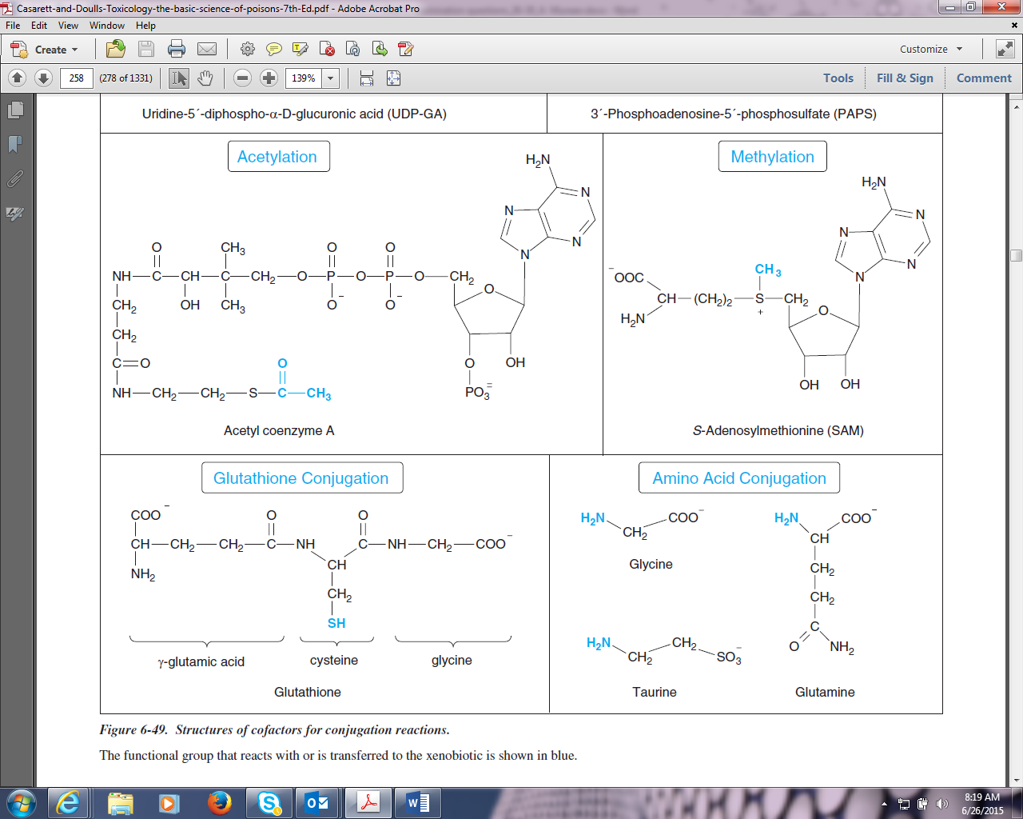

27. From 1973 to 1977, the average annual incidence rate of lung cancer in Connecticut was 45.9 per 100,000. The average annual prevalence was 23.0 per 100,000. From these values, what is the average duration of survival after being diagnosed with lung cancer?
A) 2 years
B) 6 months
C) 1 year
D) 8 years
E) 4 years

Prevalence = Incidence * Average duration of Disease
P = I * D
D = P/I
D = 23/100,000
45.9/100,000/yr
D = 0.5 yr = 6 months

28. Of the more than 40 cytochrome P450 isozymes, which 6 account for the majority of xenobiotic metabolism in humans?
A) CYP1E1, CYP2B1, CYP2B19, CYP2F1, CYP3A7, CYP4A6
B) CYP1A1, CYP2A6, CYP2B6, CYP2D6, CYP2F2, CYP4B2
C) CYP1B2, CYP2C6, CYP2F2, CYP3A2, CYP3A4, CYP4A2
D) CYP1A2, CYP2C9, CYP2C19, CYP2D6, CYP2E1, CYP3A4
E) CYP1A1, CYP2C8, CYP2F2, CYP3A7, CYP4A2, CYP4A6

Pg. 221 of C&D, Table 6-9:

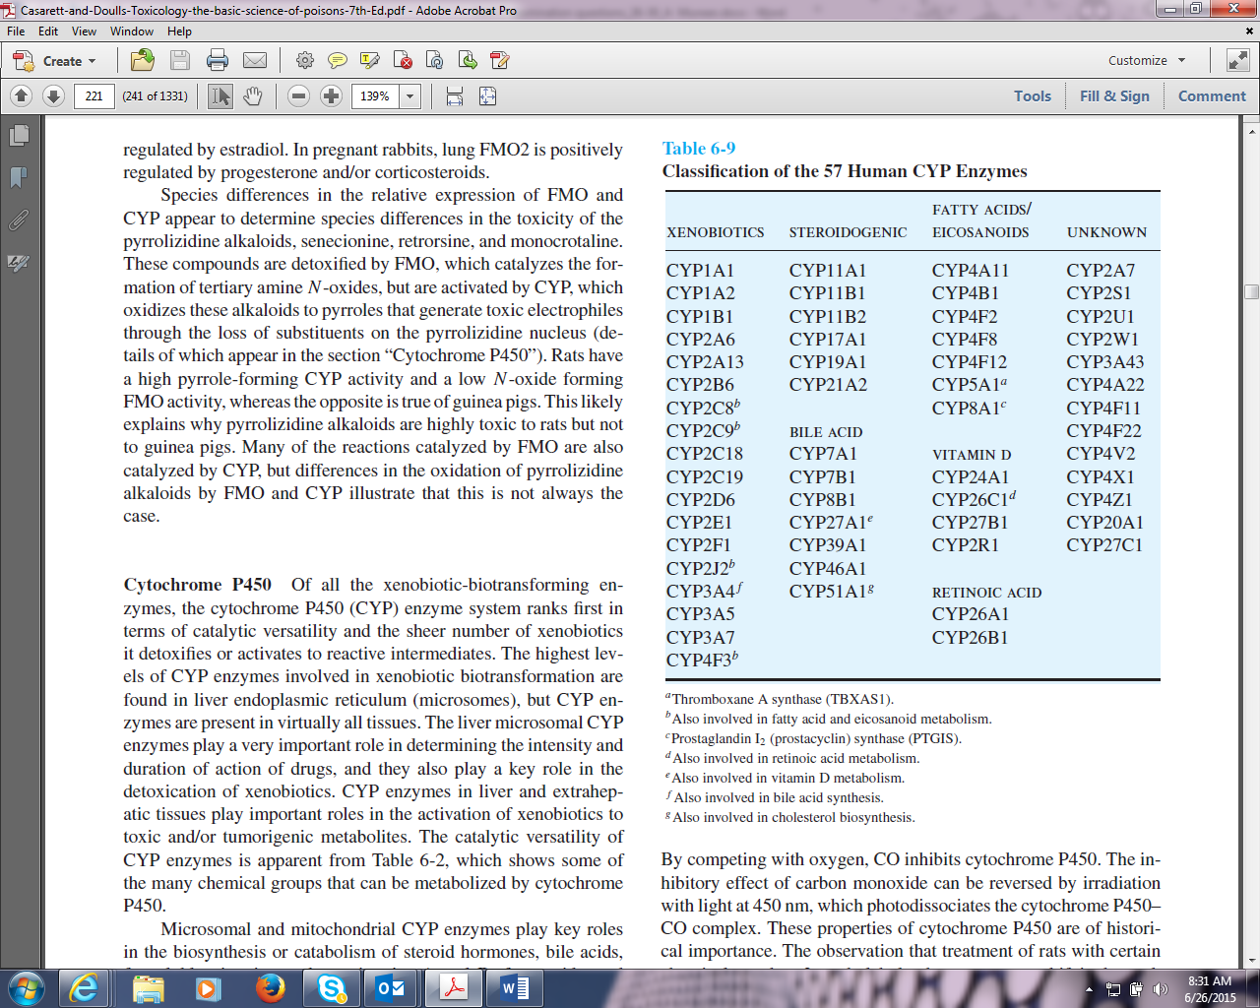

29. Which of the following conditions represents a manifestation of moderate chronic fluoride toxicity?
A) osteomalacia
B) osteosclerosis
C) osteopetrosis
D) osteopenia
E) osteolysis

Pg. 1222 of C&D: “Stage 1 skeletal fluorosis is characterized by occasional stiffness, pain in joints or some Osteosclerosis of the pelvis and vertebra.”

30. Intoxication from consumption of wild cherry or apricot pits would best be treated by
A) hyperbaric oxygen
B) artificial respiration
C) inhalation of amyl nitrite
D) intravenous sodium nitrite and sodium thiosulfate
E) oral sodium nitrate

The seeds in wild cherry and apricot pits have amygdalin which breaks down into cyanide in the human body. To treat cyanide in the human body, nitrite and thiosulfate are the antidotes per Table 1.1, pg. 6 in C&D:
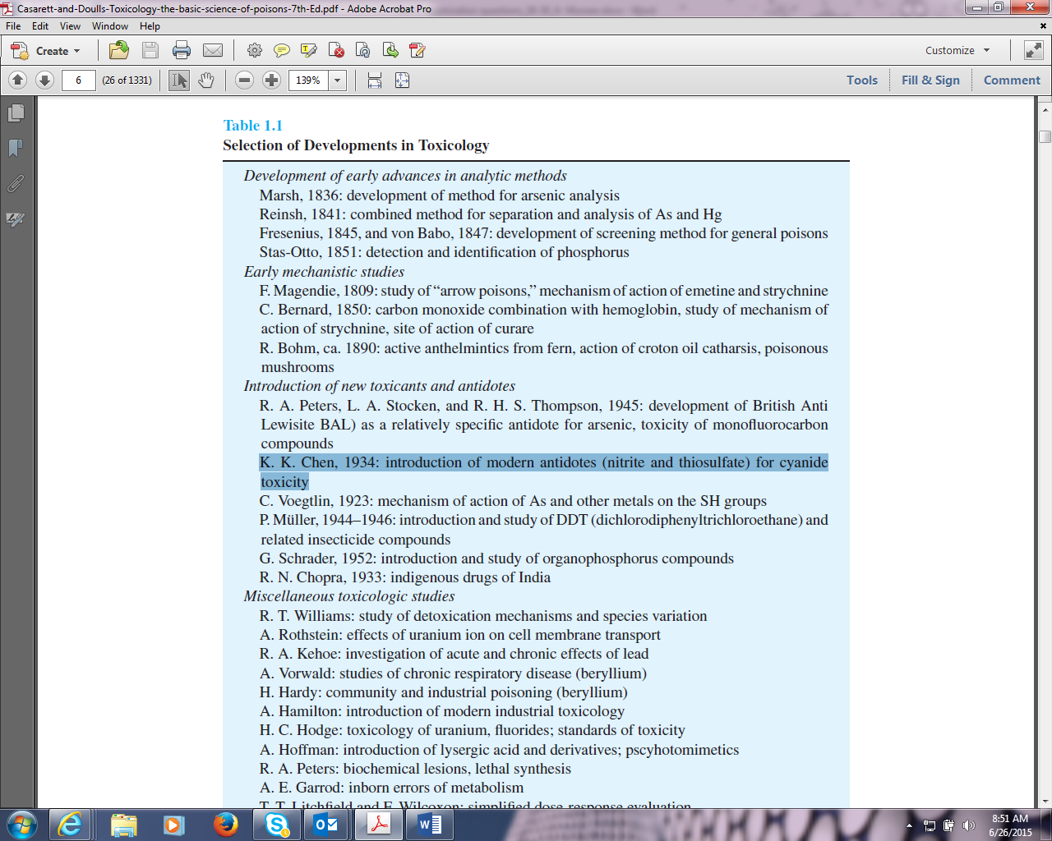

31. Drug X is available as a 2.5% solution for intravenous administration. The desired dosage of this drug is 5 mg/kg. What volume of drug should be injected if the patient weighs 50 kg?
A) 0.2 ml
B) 1.0 ml
C) 2.0 ml
D) 10 ml
E) 20 ml
Concentration solute (w/v %) = mass of solute (g)/ volume of solution (mL)*100
2.5%=0.250g/X *100
X=10mL
2.5% = 2.5 grams per 100 mL or 0.025 grams/mL, you intend on injecting the patient with 5 mg/kg. The patient weighs 50 kg; therefore, the total dose is 0.25 grams. 0.25 grams / 0.25 grams = 10 mL

32. The phrase that best defines "toxicodynamics" is the
A) linkage between exposure and dose
B) linkage between dose and response
C) dynamic nature of toxic effects among various species
D) dose range between desired biological effects and adverse health effects
E) loss of dynamic hearing range due to a toxic exposure
(p. 117) Toxicokinetics refers to the processes of absorption, distribution, elimination, and metabolism of a toxicant. Toxicodynamics refers to the actions and interactions of the toxicant within the organism and describes processes at organ, tissue, cellular, and molecular levels.

33. Which of the following was banned under the Delaney clause of the Food Additive Amendment of 1958?
A) butylated hydroxytoluene
B) sulfamethazine
C) cyclamate
D) phytoestrogens
E) aflatoxin
(Mixed with saccharine as a artificial sweetener)
(p. 1205) Delaney clause, which prohibits the approval of regulated food additives “found to induce cancer when ingested by man or animals” [sections 409(c)(3)(A), 706(b)(5)(B), and 512(d)(1)(H)].
(p. 1206) In the end, very few substances have been disapproved or banned because of the Delaney clause. Two indirect food additives (Flectol H and mercaptoimidazoline) that migrate from packaging material were banned. Among direct additives, safrole, cinnamyl anthranilate, thiourea, and diethylpyrocarbonate were banned because of the Delaney clause, diethylpyrocarbonate because it forms urethane.

34. Which of the following is NOT a characteristic of active transport?
A) blocked by saxitoxin
B) movement against a concentration gradient
C) exhibits a transport maximum
D) energy dependent
E) selectivity
(p. 134) Active Transport Active transport is characterized by: (1) movement of chemicals against electrochemical or concentration gradients, (2) saturability at high substrate concentrations, (3) selectivity for certain structural features of chemicals, (4) competitive inhibition by chemical cogeners or compounds that are carried by the same transporter, and (5) requirement for expenditure of energy, so that metabolic inhibitors block the transport process.
(p. 1222) Saxitoxin, originally isolated from toxic Alaskan butter clams (Saxidomus giganticus) is actually a family of neurotoxins and includes neosaxitin and gonyautoxins 1 through 4. All block neural transmission at the neuromuscular junction by binding to the surface of the sodium channels and interrupting the flow of Na+ ions; AV nodal conduction may be suppressed, there may be direct suppression of the respiratory center and progressive reduction of peripheral nerve excitability.

35. Which of the following is NOT an initiating event in carcinogenesis?
A) DNA adduct formation
B) DNA strand breakage
C) mutation of proto-oncogenes
D) oxidative damage of DNA
E) mitogenesis

31. Drug X is available as a 2.5% solution for intravenous administration. The desired dosage of this drug is 5 mg/kg. What volume of drug should be injected if the patient weighs 50 kg?
A) 0.2 ml
B) 1.0 ml
C) 2.0 ml
D) 10 ml
E) 20 ml
Concentration solute (w/v %) = mass of solute (g)/ volume of solution (mL)*100
2.5%=0.250g/X *100
X=10mL

32. The phrase that best defines "toxicodynamics" is the
A) linkage between exposure and dose
B) linkage between dose and response
C) dynamic nature of toxic effects among various species
D) dose range between desired biological effects and adverse health effects
E) loss of dynamic hearing range due to a toxic exposure
(p. 117) Toxicokinetics refers to the processes of absorption, distribution, elimination, and metabolism of a toxicant. Toxicodynamics refers to the actions and interactions of the toxicant within the organism and describes processes at organ, tissue, cellular, and molecular levels.

33. Which of the following was banned under the Delaney clause of the Food Additive Amendment of 1958?
A) butylated hydroxytoluene
B) sulfamethazine
C) cyclamate
D) phytoestrogens
E) aflatoxin
(Mixed with saccharine as a artificial sweetener)
(p. 1205) Delaney clause, which prohibits the approval of regulated food additives “found to induce cancer when ingested by man or animals” [sections 409(c)(3)(A), 706(b)(5)(B), and 512(d)(1)(H)].
(p. 1206) In the end, very few substances have been disapproved or banned because of the Delaney clause. Two indirect food additives (Flectol H and mercaptoimidazoline) that migrate from packaging material were banned. Among direct additives, safrole, cinnamyl anthranilate, thiourea, and diethylpyrocarbonate were banned because of the Delaney clause, diethylpyrocarbonate because it forms urethane.

34. Which of the following is NOT a characteristic of active transport?
A) blocked by saxitoxin
B) movement against a concentration gradient
C) exhibits a transport maximum
D) energy dependent
E) selectivity
(p. 134) Active Transport Active transport is characterized by: (1) movement of chemicals against electrochemical or concentration gradients, (2) saturability at high substrate concentrations, (3) selectivity for certain structural features of chemicals, (4) competitive inhibition by chemical cogeners or compounds that are carried by the same transporter, and (5) requirement for expenditure of energy, so that metabolic inhibitors block the transport process.
(p. 1222) Saxitoxin, originally isolated from toxic Alaskan butter clams (Saxidomus giganticus) is actually a family of neurotoxins and includes neosaxitin and gonyautoxins 1 through 4. All block neural transmission at the neuromuscular junction by binding to the surface of the sodium channels and interrupting the flow of Na+ ions; AV nodal conduction may be suppressed, there may be direct suppression of the respiratory center and progressive reduction of peripheral nerve excitability.

35. Which of the following is NOT an initiating event in carcinogenesis?
A) DNA adduct formation
B) DNA strand breakage
C) mutation of proto-oncogenes
D) oxidative damage of DNA
E) mitogenesis

36. Which of the following does NOT inhibit electron transport?
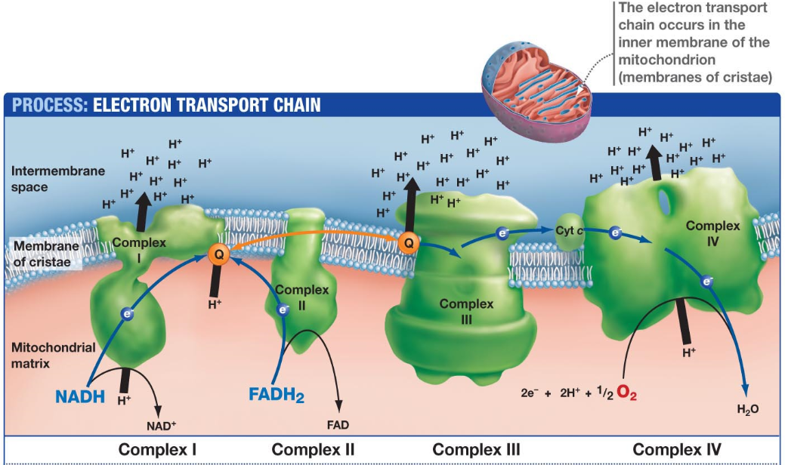
A) rotenone
Rotenone works by interfering with the electron transport chain in mitochondria. To be specific, it inhibits the transfer of electrons from iron-sulfur centers in complex I to ubiquinone. Source: https://en.wikipedia.org/wiki/Rotenone

Several chemicals impede these processes, interfering with mitochondrial ATP synthesis. These chemicals are divided into five groups. (C&D 7th Ed., at pp. 71-72)

Class A chemicals interfere with the delivery of hydrogen to the electron transport chain. For example, fluoroacetate inhibits the citric acid cycle and the production of reduced cofactors.

Class B chemicals such as rotenone and cyanide inhibit the transfer of electrons along the electron transport chain to oxygen.

Class C agents interfere with oxygen delivery to the terminal electron transporter, cytochrome oxidase. All chemicals that cause hypoxia ultimately act at this site.

Class D chemicals inhibit the activity of ATP synthase, the key enzyme for oxidative phosphorylation.

Class E chemicals cause mitochondrial DNA injury, and thereby impairing synthesis of specific proteins encoded by the mitochondrial genome (e.g., subunits of complex I and ATP synthase). These include ethanol (when chronically consumed) and dideoxynucleoside antiviral drugs used against AIDS, such as zidovudine.

B) succinate
Succinate does not inhibit electron transport. It is a reaction product and reactant in the Citric Acid Cycle, which occurs in the mitochondrial matrix, outside the cristae (i.e., Acetyl CoA + oxaloacetate Citrate Isocitrate alpha-ketoglutarate Succinyl CoA Succinate Fumarate Malate Oxaloacetate). Source: http://www.uic.edu/classes/bios/bios100/lectures/respiration.htm

C) antimycin-A
This is an inhibitor of electron transport. It is a Class B chemical that inhibits Complex III (Cytochrome Q-cytochrome c reductase. (C&D 7th Ed., at p. 72)

D) formate
This is an inhibitor of electron transport. It is a Class B chemical that inhibits Complex IV (Cytochrome oxidase). (C&D 7th Ed., at p. 72)

E) azide
This is an inhibitor of electron transport. It is a Class B chemical that inhibits Complex IV (Cytochrome oxidase). (C&D 7th Ed., at p. 72)

37. Reabsorption of toxicants does NOT occur through
A) entero-hepatic recirculation
Secretion into biliary ducts is usually but not always a prelude to toxicant clearance by excretion in feces or urine. Exceptions occur when compounds such as arsenic, thallium, etc. are repeatedly delivered into the intestinal lumen via bile, efficiently absorbed from the intestinal lumen, and then redirected to the liver via portal blood, a process known as enterohepatic cycling. (C&D 7th Ed., at p. 561)

B) glomerular filtration
Toxic compounds are excreted in urine by the same mechanisms the kidney uses to remove the end products of intermediary metabolism from the body including glomerular filtration, tubular excretion by passive diffusion, and active tubular secretion. In general, the excretion of small molecular weight (<350 Da), water-soluble compounds is favored in urine. (C&D 7th Ed., at p. 151)

C) diffusion
The penetration of toxicants into cells occurs by passive diffusion or special transport processes. Small water-soluble molecules and ions apparently diffuse through aqueous channels or pores in the cell membrane. Lipid-soluble molecules readily permeate the membrane itself. Very polar molecules and ions of even moderate size (molecular weight of 50 or more) cannot enter cells easily except by special transport mechanisms because they are surrounded by a hydration shell, making their actual size much larger. (C&D 7th Ed., at p. 145)

D) active transport
Some toxicants selectively accumulate in certain parts of the body as a result of protein binding, active transport, or high solubility in fat. (C&D 7th Ed., at p. 145)

E) carriers for physiologic oxyanions
Carriers for the physiologic oxyanions mediate the reabsorption of some toxic metal oxyanions in the kidney. Chromate and molybdate are reabsorbed by the sulfate transporter, whereas arsenate is reabsorbed by the phosphate transporter. (C&D 7th Ed., at p. 50)

38. Which of the following does NOT uncouple oxidative phosphorylation?
A) pentachlorophenol
Pentachlorophenol was once one of the most widely used biocides in the United States, but it is now a restricted use pesticide and is no longer available to the general public. It was primarily used as a wood preservative. Source: http://www.epa.gov/ttnatw01/hlthef/pentachl.html

PCP is a Class D chemical (Inhibitor of ADP phosphorylation acting on/as). Specifically, it is part of the subclass of chemicals that dissipate the mitochondrial membrane potential (uncouplers). PCP is a recognized cationophore. (C&D 7th Ed., at p. 72)

B) dinitrophenol
2,4-Dinitrophenol (DNP) is reported to cause rapid loss of weight, but unfortunately is associated with an unacceptably high rate of significant adverse effects. DNP is sold mostly over the internet under a number of different names as a weight loss/slimming aid. It causes uncoupling of oxidative phosphorylation; the classic symptom complex associated with toxicity of phenol-based products such as DNP is a combination of hyperthermia (elevated body temperature), tachycardia (rapid heart beat), diaphoresis (perspiration) and tachypnea (rapid breathing), eventually leading to death. Fatalities related to exposure to DNP have been reported since the turn of the twentieth century. To date, there have been 62 published deaths in the medical literature attributed to DNP. Source: http://www.ncbi.nlm.nih.gov/pubmed/21739343

DNP is a Class D chemical (Inhibitor of ADP phosphorylation acting on/as). Specifically, it is part of the subclass of chemicals that dissipate the mitochondrial membrane potential (uncouplers). DNP is a recognized cationophore. (C&D 7th Ed., at p. 72)

C) aconitase
This is an enzyme of the Citric Acid Cycle. It catalyzes the stereospecific isomerization of citrate to isocitrate. Source: http://www.uic.edu/classes/bios/bios100/lectures/respiration.htm

D) salicylate
Salicylates are nonsteroidal anti-inflammatory drugs. They inhibit the synthesis of prostaglandin and other mediators in the process of inflammation and have anti-inflammatory, antipyretic (fever reducing) and analgesic (pain relieving) properties. Salicylates can be used to reduce fever, pain and inflammation such as in arthritis. Source: http://www.drugs.com/drug-class/salicylates.html

Salicylate is a Class D chemical (Inhibitor of ADP phosphorylation acting on/as). Specifically, it is part of the subclass of chemicals that dissipate the mitochondrial membrane potential (uncouplers). Salicylate is a recognized cationophore. (C&D 7th Ed., at p. 72)

E) gramacidin
A group of peptide antibiotics from BACILLUS brevis. Gramicidin C or S is a cyclic, ten-amino acid polypeptide and gramicidins A, B, D are linear. Gramicidin is one of the two principal components of TYROTHRICIN. Gramicidin is particularly effective against gram-positive bacteria. Because the drug is highly hemolytic, it cannot be administered internally and so is used only on the skin as a lotion or ointment. It is used primarily in the treatment of infected surface wounds, and in eye, nose, and throat infections. It is normally given with two other antibiotics (neomycin and polymixin B) as an ophthalmic solution. Source: http://pubchem.ncbi.nlm.nih.gov/compound/16130140#section=Drug-and-Medication-Information

Gramacidin is a Class D chemical (Inhibitor of ADP phosphorylation acting on/as). Specifically, it is part of the subclass of chemicals that dissipate the mitochondrial membrane potential (uncouplers). Gramacidin is a recognized cationophore. (C&D 7th Ed., at p. 72)

39. Which of the following is NOT true regarding peroxisome proliferators?
A) they are a structurally diverse group of chemicals
The distinction between xenobiotic- and endobiotic-sensing functions is particularly blurred in the case of PPARα, which is activated by endogenous fatty acids (e.g., arachidonic acid), eicosanoids and conjugated steroids such as dehydroepiandrosterone sulfate, as well as numerous acidic xenobiotics such as hypolipidemic fibrate drugs (e.g., clofibrate, fenofibrate, ciprofibrate), various NSAIDs,
aspirin, leukotriene receptor antagonists (MK-0571 and RG 7512), organic solvents (trichloroacetic acid), phthalate ester plasticizers, herbicides (haloxyfab, lactyofen, 2,4-dichlorophenoxyacetic acid or 2,4-D), perfluorodecanoic acid, nicotinic acid, and the potent and widely used experimental PPARα agonist Wy-14643. (C&D 7th Ed., at p. 255)

B) they cause marked induction of lipid metabolizing enzymes
When activated with ligand and complexed with RXRα, PPARα activates the transcription of several genes that encode peroxisomal enzymes involved in the β-oxidation of fatty acids, including fatty
acyl-CoA oxidase, bifunctional enzyme (enoyl-CoA hydratase/3-hydroxyacyl-CoA dehydrogenase), and fatty acid binding protein. (C&D 7th Ed., at p. 255)

C) they often are non-genotoxic hepatocarcinogens in rodents
PPARα plays a critical role in tumor formation by peroxisome proliferators as evidenced by the finding that Wy-14643 does not function as a tumor promoter in PPARα knockout mice. PPARα agonists are considered epigenetic (nongenotoxic) tumorigens because they are not mutagenic and they are not known to be converted to mutagenic metabolites. However, induction of acyl-CoA oxidase byWy-14643 and other peroxisome proliferators leads to increased production of hydrogen peroxide, which can cause oxidative stress and DNA damage that possibly play a role in some of the downstream events leading to tumor promotion. (C&D 7th Ed., at p. 256)

D) they induce hepatic CYP1A which is indicative of peroxisome proliferation
The peroxisome proliferator activated receptor alpha (PPARα), which induces CYP4 enzymes. (C&D 7th Ed., at p. 166)

E) they operate via the peroxisome proliferator activated receptor
Activation of PPARα is required but apparently not sufficient to lead to liver tumor formation. Other key events include increased oxidant production (such as increased peroxisomal H2O2 production),
increased cell proliferation (which fixes mutations), and suppression of apoptosis (which prevents the removal of genetically damaged cells and permits clonal expansion). (C&D 7th Ed., at p. 256)

40. Permissible Exposure Limits are
A) promulgated by the Occupational Safety and Health Administration and have the force of law
While the U.S. Occupational Safety and Health Administration (OSHA) has established legally enforceable permissible exposure limits (PELs) for over 100 solvents, most PELs are outdated. (C&D 7th Ed., at p. 983)

B) identical to and interchangeable with Short Term Exposure Limits
The ACGIH’s TLVs are for an 8-hour workday, 40-hour workweek and are designed to be protective
for a working lifetime, whereas its short-term exposure limits (STELs) and ceiling values are designed to protect against the acute effects of high-level, short-term solvent exposure. (C&D 7th Ed., at p. 983)

C) authorized under the Toxic Substances Control Act
PELs are authorized under the U.S. Occupational Safety and Health Act, not the Toxic Substances Control Act.

D) promulgated by the Environmental Protection Agency
EPA has authority under section 5 of TSCA to issue consent orders, which may require, among other things, that potentially exposed employees of the company that submitted the pre-manufacture notification (PMN) must wear specified respirators unless actual measurements of the workplace air show that air-borne concentrations of the PMN substance are below a New Chemical Exposure Limit (NCEL) that is established by EPA to provide adequate protection to human health. EPA modeled its comprehensive NCELs provisions after OSHA’s PELs and includes requirements addressing performance criteria for sampling and analytical methods, periodic monitoring, respiratory protection, and recordkeeping. EPA generally extends these section 5(e) Order requirements to other manufacturers and processors of the same chemical substances via a section 5(a)(2) Significant New Use Rule (SNUR). Source: http://www.epa.gov/oppt/newchems/pubs/ncelmain.htm

E) are directly adopted from the American Conference of Governmental Industrial Hygienists Threshold Limit Value list
OSHA recognizes that many of its permissible exposure limits (PELs) are outdated and inadequate for ensuring protection of worker health. Most of OSHA’s PELs were issued shortly after adoption of the Occupational Safety and Health (OSH) Act in 1970, and have not been updated since that time. Section 6(a) of the OSH Act granted the Agency the authority to adopt existing Federal standards or national consensus standards as enforceable OSHA standards. Most of the PELs contained in the Z-Tables of 29 CFR 1910.1000 were adopted from the Walsh-Healy Public Contracts Act as existing Federal standards for general industry. These in turn had been adopted from the 1968 Threshold Limit Values (TLVs®) of the American Conference of Governmental Industrial Hygienists (ACGIH®).

